6. CONVOLUTION AND SAMPLING TECHNIQUES
Experiment 6.1 Convolution of Continuous Time Signals
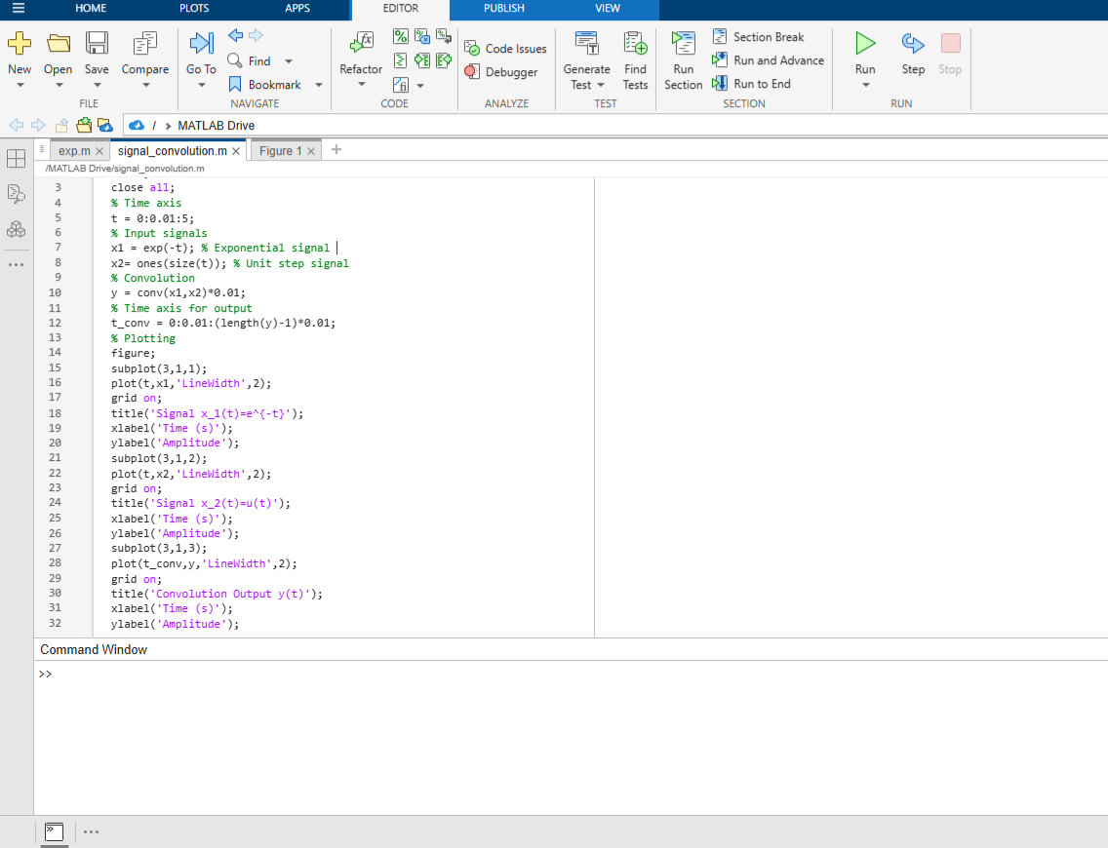
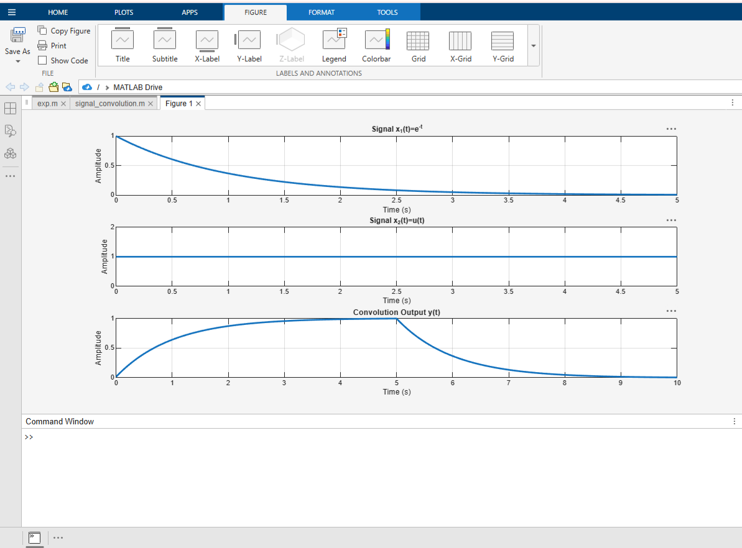

Experiment 6.3
Sampling Theorem Verification
